Requirement Gathering and Analysis Phase
Technology Stack (Architecture & Stack)

Date | 27 July 2025
Team ID | LTVIP2025TMID47711
Project Name | Project - HouseHunt
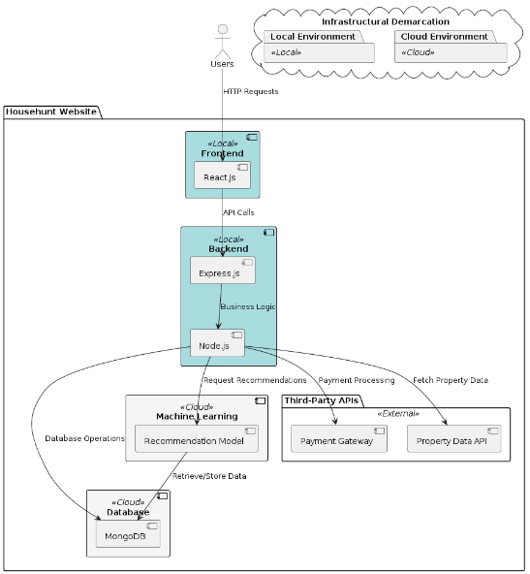
Technical Architecture:

Table-1 : Components & Technologies:
S.No | Component | Description | Technology
 | Search and Filters | Search for properties by location, price range, and property type. | React, Node.js, Express, MongoDB
 | User Accounts & Communication | Create an account with Gmail authentication and save searches. | React, Node.js, Express, MongoDB, OAuth
 | User Accounts & Communication | Receive confirmation email upon registration. | React, Node.js, Express, MongoDB,  Nodemailer
 | Market Insights | View an indicator on listings of current and past price changes in the area. | React, Node.js, Express, MongoDB, Chart.js
 | Environmental data | See an overlay on listings showing estimated noise levels and air quality. | React, Node.js, Express, MongoDB,  AirVisual API
 | Detailed Listings | View detailed listings with high-quality photos and videos. | React, Node.js, Express, MongoDB,  AWS S3
 | User Accounts & Communication | Contact sellers or landlords directly through the platform. | React, Node.js, Express, MongoDB, Socket.io
 | Neighbourhood Insights | Gain insights into the surrounding neighbourhood, including schools, parks, and amenities. | React, Node.js, Express, MongoDB, Google Maps API.
 | Community Rating, Reviews and Feedback | Read reviews from other users about neighbourhoods and property management companies. | React, Node.js, Express, MongoDB, Yelp API
 | School district & commute overlays | Filter listings based on commute time to specific locations (work, school). | React, Node.js, Express, MongoDB, Google Distance Matrix API.
 | Dashboard for sellers, agents and landlords | Host a live, interactive open house directly on the platform. | React, Node.js, Express, MongoDB, WebRTC
 | Notifications | Receive notifications when new listings matching saved searches become available. | React, Node.js, Express, MongoDB, Firebase Cloud
 | Security Considerations Enforcement | Deal only with legitimate and authorized individuals, ensuring property information is secure. | React, Node.js, Express, MongoDB, JWT

Table-2: Application Characteristics:
S.No | Characteristics | Description | Technology
 | Open-Source Frameworks | List the open-source frameworks used | React, Node.js, Express, MongoDB, OAuth, Chart.js, AirVisual API, AWS S3, Socket.io, Google Maps API, Yelp API, Google Distance Matrix API, WebRTC, Firebase Cloud, JWT
 | Security Implementations | List all the security / access controls implemented, use of firewalls etc. | JWT, OAuth, Nodemailer
 | Scalable Architecture | Justify the scalability of architecture (3 – tier, Micro-services) | React, Node.js, Express, MongoDB
 | Availability | Justify the availability of application (e.g. use of load balancers, distributed servers etc.) | React, Node.js, Express, MongoDB,  Firebase Cloud
 | Performance | Design consideration for the performance of the application (number of requests per sec, use of Cache, use of CDN’s) etc. | React, Node.js, Express, MongoDB, AWS S3

